**Bank Management System**

**Database Design**

**Entities of Bank Management System**

1. Accountant
2. Account
3. UserInfo

**Accountant**

* **Attributes:**

FirstName

LastName

Email

Password

* **Relationship**

One **Accountant** Adds More Than One **User** (**one to many**).

**User**

* **Attributes:**

UID (Primary Key)

FirstName

LastName

Email

Password

Mobile

Address

* **Relationship**

Many **Users** have many **Accounts (many to many)**

**Account**

* **Attributes:**

AccountNumber (Primary Key)

Balance

UID (Foreign Key)

* **Relationship**

Many **Accounts** are managed by one **Accountant (many to one)**

**Table Structure**

**1.) Accountant**

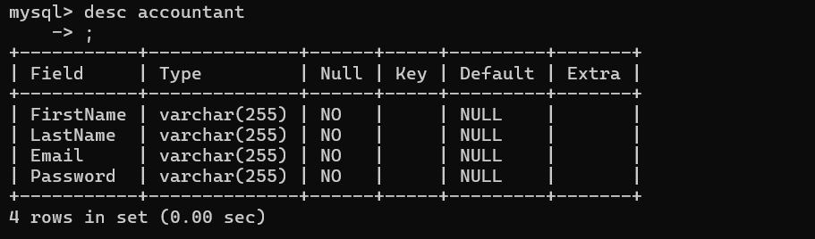

**2.) UserInfo**

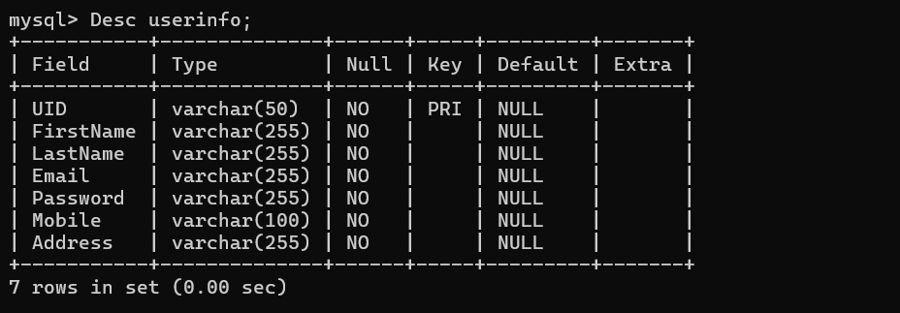

**3.) Account**

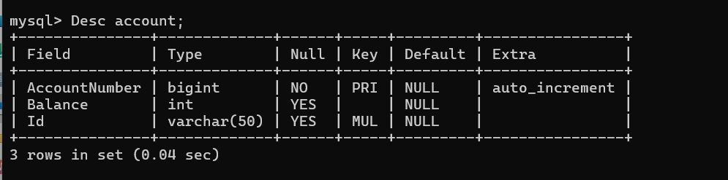

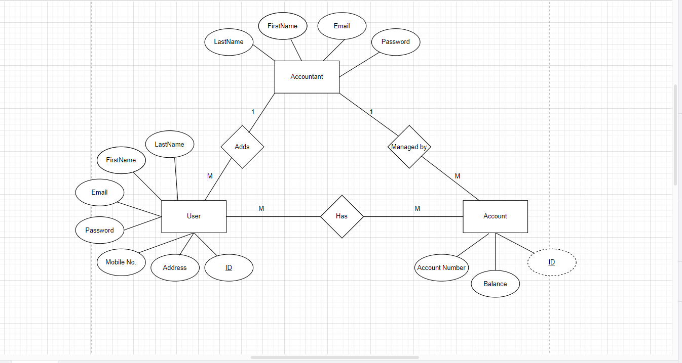**ER Diagram**

**Creating the tables for each entity**

*Create table Accountant (*

*FirstName varchar(255) not null,*

*LastName varchar(255) not null,*

*Email varchar(255) not null,*

*Password varchar(255) not null*

*);*

*Create table UserInfo (*

*UID varchar(50) primary key,*

*FirstName varchar(255) not null,*

*LastName varchar(255) not null,*

*Email varchar(255) not null,*

*Password varchar(255) not null,*

*Mobile varchar(100) not null,*

*Address varchar(255) not null*

*);*

*Create table Account (*

*AccountNumber bigint primary key auto_increment,*

*Balance int,*

*Id varchar(50),*

*foreign key(Id) references UserInfo(UID) on delete cascade);*

*);*